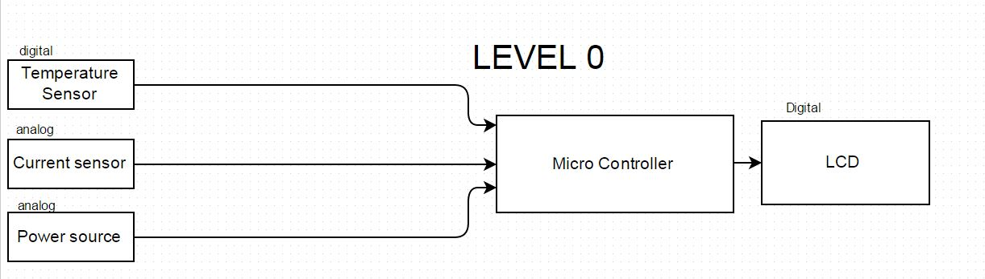

|  |  |
| --- | --- |
| Module | Thermal Monitoring System |
| Input | Analog input signal: 0-5 V  Digital input signal: 0-5V  Power: 5V |
| Output | Digital Voltage |
| Functionality | Monitoring and displaying current and temperature for a bus bar system.  Current range: 0-80 A  Temperature range : 0-120˚C |

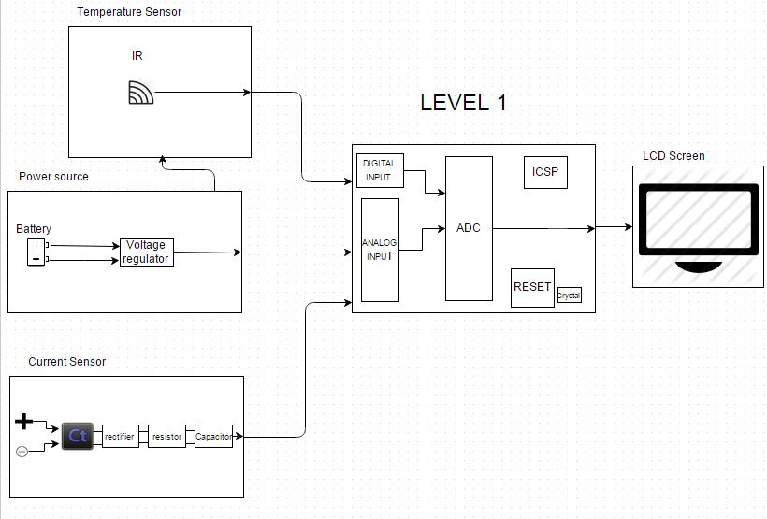

Current Sensor: Level 1

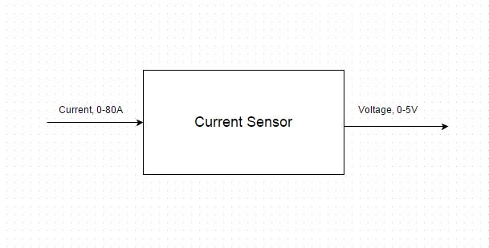

|  |  |
| --- | --- |
| Module | Current sensor |
| Input | Current : 0-80A |
| Output | Digital Voltage signal: 0-5V |
| Functionality | Convert high amperage to lower voltage for analog input of microcontroller |

Power Source: Level 1

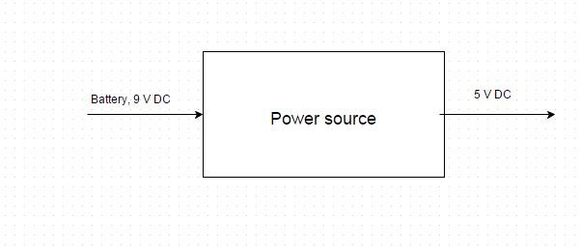

|  |  |
| --- | --- |
| Module | Power source |
| Input | Battery : 9V DC |
| Output | 5V DC |
| Functionality | Regulates Voltage for proper specifications of micro controller. |

Temperature Sensor: Level 1

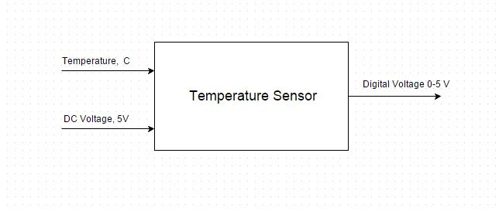

|  |  |
| --- | --- |
| Module | Temperature sensor |
| Input | 5V DC  Temperature: 0-100˚ C |
| Output | Digital signal: 5V |
| Functionality | Read temperature from Bus bar for monitoring. |

Microprocessor: Level 1

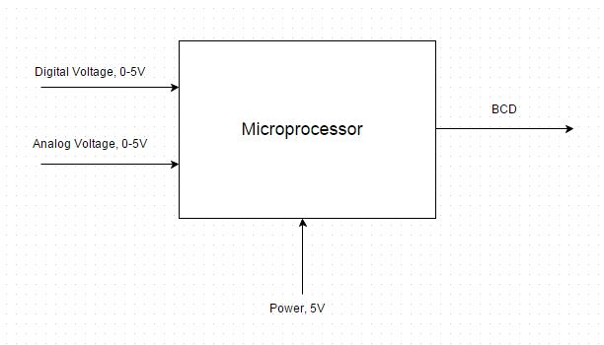

|  |  |
| --- | --- |
| Module | Microprocessor |
| Input | Digital signal: 5V DC  Analog signal: 5V DC  Power: 5V DC |
| Output | BCD |
| Functionality | Analog to Digital converting  Take input from temperature sensor to convert to BCD using C language coding.  Take input from current sensor to convert to BCD using C language coding. |

Microprocessor: Level 1

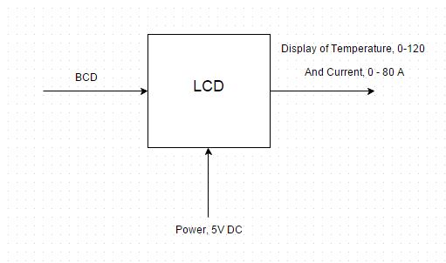

|  |  |
| --- | --- |
| Module | LCD |
| Input | BCD  Power: 5V |
| Output | Text display |
| Functionality | Display the current and temperature of the system on the screen for monitoring. |